Soil Kit Activity

Subject:  Related Subjects: | Grade Level(s):  Length of Lesson: | Type: Inquiry / Design / Project  Keywords:

Lesson Overview
Use this section to describe at a high level what the lesson is. Should be no more than 3-4 lines.

Lesson Focus
What is the central question or phenomenon being investigated? What problem are they trying to solve?

Lesson Objective(s) | By the end of this lesson, students will…  - Learn the concepts of attraction, repulsion, friction, polarity, and charge.

Lesson Timing

5 minutes | Introduce the Lesson
30 minutes | ...

Materials | - Material 1 (# per student, per group of # students, per class)
Instructor Prep | - Step 1
Related Resources | - List related lessons/ppts etc available from USC or outside, trusted orgs

Lesson Plan

Introduction
Introduce students to the learning goals and make connections to past and present learning experiences. Stimulate interest and prompt students to identify their own questions about the topic. This can link the lesson to real world examples, introduce associated STEM careers, and assess their prior knowledge on the topic.

- Step 1

Procedure
1. Pour 100 ml of dry soil into the graduated cylinder. Do not pack the soil down.

2. Once exactly 100ml of soil has been measured, transfer the soil into the empty beaker or glass jar.

3. Gently tilt the beaker and orient the dry soil so that it is sloped against one side of the beaker and the bottom of the beaker is visible.

4. Rinse your graduated cylinder three times to remove all dust contamination. Fill the cylinder EXACTLY to its top measuring line
(50ml for the 50ml graduated cylinder or 100ml for 100ml graduated cylinder)

5. Slowly and carefully add water to the soil in the beaker, taking care to pour at the point where the soil is shallowest in the beaker.

6. CAUTION: This is the hardest part! Continue adding water very gradually until the soil has completely soaked up as much water as it will hold. This sometimes takes ten minutes! Verify there is no dry soil remaining by looking at the soil through the bottom and the sides of the beaker(if you are using the 50ml and use all the water. Refill it to 50ml and continue)

7. Calculate your pore space percentage by subtracting the water remaining from your original amount and then divide that answer by the original amount (if you needed to refill the 50ml cylinder your original amount would be 100ml) and multiply by 100:

Original amount in cylinder – remaining water in cylinder x 100
Original amount in cylinder

1. Place approximately two tablespoons of soil in your hand.

2. Use the water squeeze bottle to saturate (completely wet) the soil.

3. Tilt your hand and allow any excess water to run off. Notice the color of this runoff. If it appears "dirty", then soil sediment is contained within the water.

4. Rinse the soil again and look at the runoff. Rinse as many times as you need to before the water no longer changes color. The water won’t necessarily be clear.

5. Count the number of times that the runoff contained sediment (appeared dirty). Multiply this number times 3%.

6. Example: If the water contained sediment (appeared dirty) ten times before it ran clear, you would multiply 10 x 3% = 30%. This number represents the combined percentage of silt and clay in your sample. The sample contains approximately 15% each (30% total) of silt and clay.

7. In this example, the sand percentage would be approximately 70%, silt would be 15% and clay would be 15%. Using the texture triangle, we would classify this soil sample as Sandy Loam. (70% sand, 15% silt, 15% clay)

Activity 3 - pH
1. Students should place approximately 2 teaspoons of dry soil into cavity dish. It should be enough to fill the cavity half full.
2. Add enough Poly-D reagent to just saturate the sample
3. Tilt the cavity dish from side to side to mix the reagent and the soil
4. After two minutes read the pH of the soil in bright light by matching the solution color with the color chips on the reaction chart.

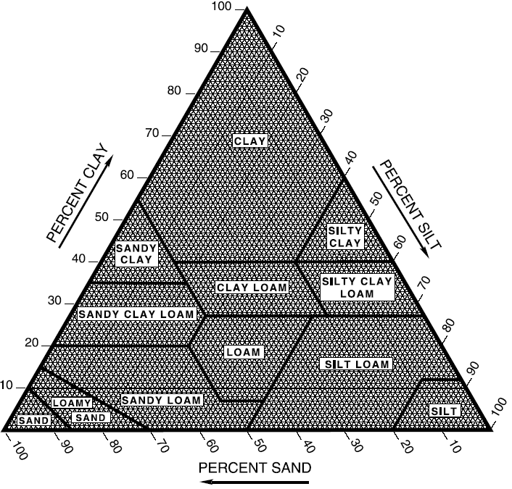

Wrap-up
End the lesson with some final discussions about what students designed/discovered. Connect their activity back to the focus question/problem, real world examples, and STEM careers.

Also include notes about any special cleanup considerations

Lesson Background for Teachers

Suggested Real-World STEM Connections
- List possible related Role Models in STEM (with details and links to more reading). Give suggestions for examples of scientists/engineers who are from underrepresented groups in STEM in related careers.
- List related real-world engineering problems and examples

Lesson Variations and Options
Include descriptions of alternative methods or ways to present things.

Explanation
Describe the background concepts and explanations behind the lesson. This can be more in depth than a teacher/instructor would actually share with students.

Key Concepts and Vocabulary
- Word 1: Grade Appropriate Definition
- Word 2: Grade Appropriate Definition

Safety Notes
- Safety instruction

